My Family
The topic of this unit of work, which will be taught this week and next week is My Family.
The unit of work caters for Stage 1, Year 1 and Year 2.
The activities are sequenced in the same way as they are sequenced at school.
Activity 1: The first activity is an introductory video about family’s members. It is suggested that your child watches the video multiple times to master the new vocabulary and being exposed to possessive pronouns: Mio (my masculine), Mia (my feminine), Miei (my plural). The pronouns are aimed in particular to Year 2 students; however if your child is in Year 1 let them to be exposed to it.
Activity 2: This activity is a link to a YouTube video, your child does not need to be able to understand each word spoken in the video. The aim of the video is to consolidate the vocabulary presented in activity 1 in a fun way.
https://www.youtube.com/watch?v=hUEAN3B02Aw
Vocabulary of the lesson:
- Questa è la mia mamma-This is my mum
- Questo è il papà-this is my dad
- Questa è mia sorella-this is my sister
- Questo è mio fratello-this is my brother
- Questa è mia nonna-this is my grandmother
- Questo è mio nonno-this is my grandfather
- Questo è il mio cane-this is my dog
- Genitori-parents
Activity 3: This activity comprises two files: sound track (number 44) and page with an illustration (Page 3). Your child should listen to the sound track while reading along.
Activity 4: This is writing activity (page 4), your child is asked to fill in the blanks in the worksheet. There is no need to print the file; the activity can be completed in your child’s scrap book.
See below the answers.
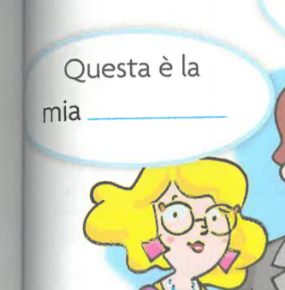 Questa è la mia mamma.
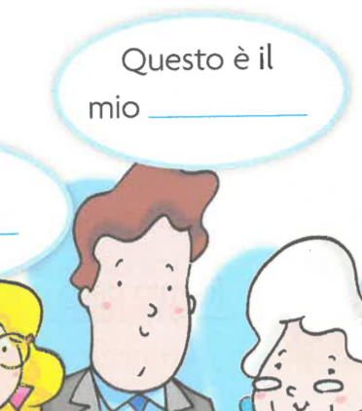 Questo è il mio papà.
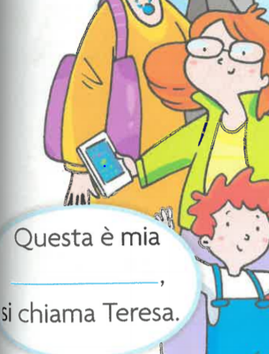Questa è mia sorella.
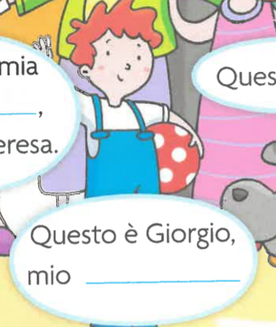 Questo è Giorgio, mio fratello.
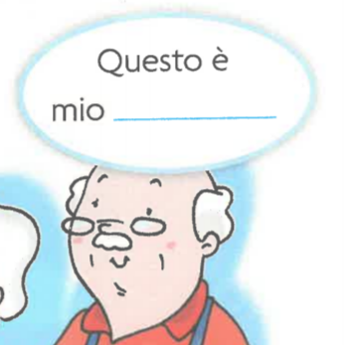Questo è mio nonno.
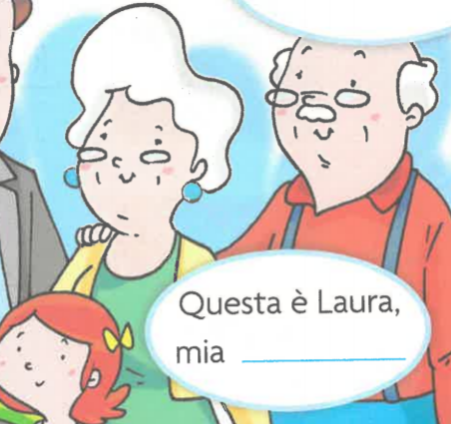 Questa è Laura, mia nonna.
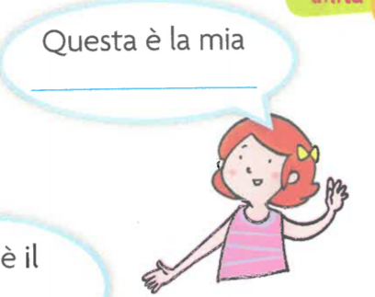Questa è la mia famiglia.

Activity 5: This a matching activity (page 5); your child has to colour in the right word next to each picture. If you do not wish to print the worksheet this activity can also be done orally.
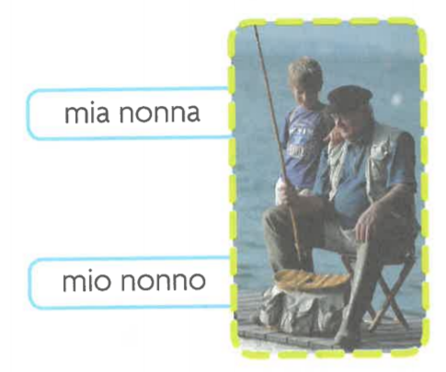

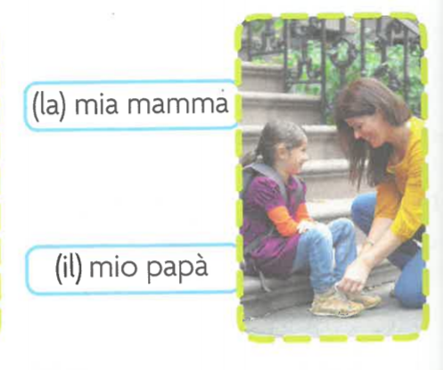
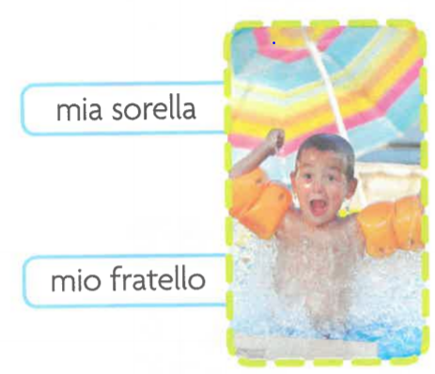

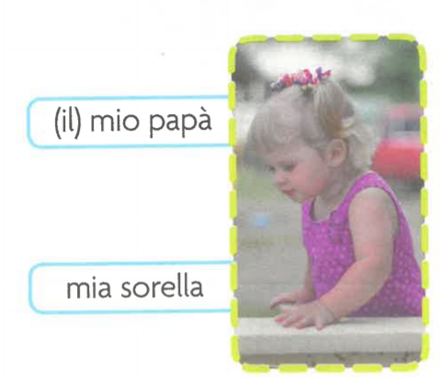
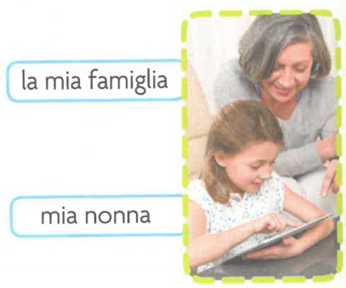
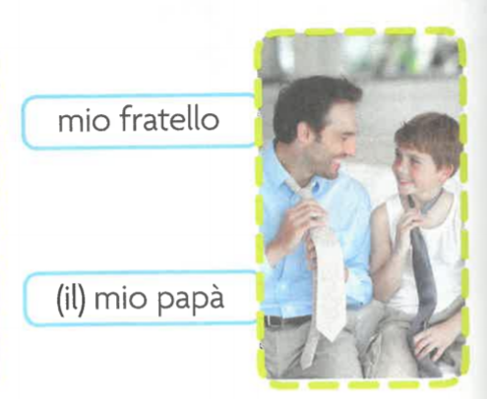

Activity 6: This activity is a listening exercise where your child matches the right picture with the right description; it is suggested your child listens to the description more than one time before completing the activity. (Sound track 46 and page 7)
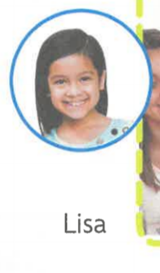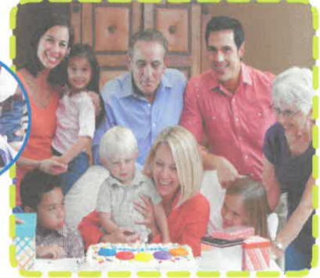
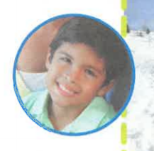

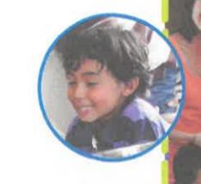

Activity 6: This is a game online; your child will receive immediate feed by the game online.

Your child will find the answers to the exercises in a folder called Answers key.

