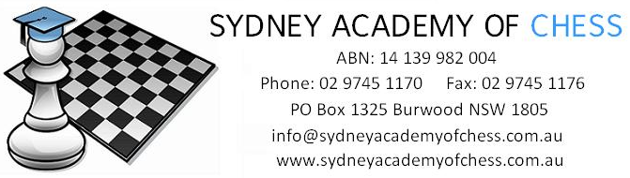

Dear Parents,

Sydney Academy of Chess is considering running chess coaching at your son/daughters school,
St Martin’s Primary School (Davidson). This class will run each week on Tuesday lunchtime from 12:45pm-1:45pm, starting in Term 2.

Chess is a valuable activity for children, developing their logical thinking skills, concentration and discipline, as well as being a source of much enjoyment! What great way to combine learning and fun!

These classes begin with an interactive lecture by one of our experienced coaches. During the second half of the lesson children play games against each other, putting newly learned strategies into practice. As the term progresses and the children become proficient in all the basics, the lectures will move on to more complex ideas such as strategy, middle game ideas and chess technique. Each student in the Chess program will also receive access to Chess Squad
https://www.chesssquad.com/ which is an online teaching/playing platform.

The cost for the coaching is $12 per lesson per child. There are approx. 8-10 lessons during each term.

If you are interested in your child taking part in this activity, please fill in the form below and email to enrol@sydneyacademyofchess.com.au

Thanks and regards,

Sydney Academy of Chess

-------------------------------------------------------------------------------------------------------------
EXPRESSION OF INTEREST FOR CHESS CLASSES – 2021
St Martin’s Primary School (Davidson)

I would like my child to take part in the chess coaching organised by the Sydney Academy of Chess in 2021 and give permission for my contact details to be used for this purpose.

Please print clearly
Student Name: ______________________________________ Year Group/Class: ___________
Parent Name: _______________________________________ Contact #: _________________
Email Address:_______________________________________
Parent Signature: __________________________________________

